C++ Based Reminder System
Faraz Satria Nugraha, Rasendriya Deron Hafizh Surono, Nadhifa Azka Sherin
#Group 2, IUP 1 Universitas Gadjah Mada
Indonesia

Abstract - Managing daily tasks, events, and deadlines can be difficult when schedules are unstructured, potentially causing users to miss important activities. This report presents a lightweight reminder system developed using C++. The system allows users to add, view and delete reminders while organizing them into different groups and assigning priority levels. Each reminder contains information such as its title, time, and urgency. The system operates offline and is designed mainly for individual users who need a simple method of managing daily activities. We also have developed a flowchart to allow better viewing of the system’s main functions, including reminder creation, viewing etc.
- Introduction
In everyday life, many individuals often miss important tasks, events, or deadlines due their poor time management and unstructured schedule. This can cause many problems in social life, education, and even career.
As a solution to overcome these issues, a lightweight time reminder program was developed using C++ programming language. This program is specifically designed to help users record, manage, and receive timely alerts for their daily activities.
This C++ based reminder system offers several technical advantages and disadvantages, including fast performance due to the low RAM usage, an integrated deadline system, and the capability to operate offline so it can be used at any time. Through the development of this program, it is hoped that users will have a reminder tool that is simple, fast, and easy to use, to keep track of everyday tasks and deadlines.
- Methodology/System Design
- System Design
The reminder system was designed to be a menu-driven program. When the program starts, the reminder data structure and reminder counter are initialized. The system then displays the main menu, which provides four operations such as: adding a reminder, viewing reminders, deleting reminders, and exiting the program.

- Adding a Reminder
When the user enters a value that selects the add-reminder option, the program asks the user to select a reminder group and enter the reminder information. The information consists of the reminder title, date, time, and urgency level.

- Viewing reminders
The view-reminder option allows the user to display the stored reminders. The system first checks whether any reminders have been stored. If no reminders are available, the system displays a message saying there are no reminders. Otherwise, the stored reminders are displayed to the user.

- Deleting a reminder
The delete reminder option allows the user to remove a reminder from the system. After the user selects the reminder to be deleted, the system removes the selected reminder.
- Features
Features in the program:
- Main Reminder
The core feature of this program, user could add reminders and manage it.
- Prioritize tier
there will be 3 classes of priority that user could put in their reminder. Red indicates that this reminder is very important and very urgent. Yellow indicates that this reminder is either important but not urgent or vice versa. Green indicates that this reminder is not urgent and not that important.
- Groupings
User could put a specific reminder into the group such as a college group, events group, or personal group, so it could be more organized and would not become messy.
IV. Flowchart and Results
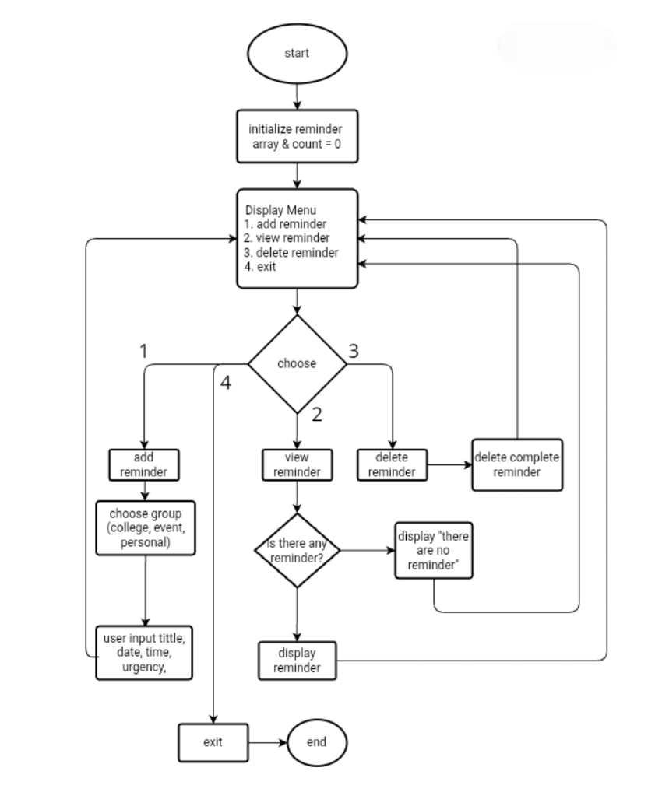
*Fig 1. Flowchart, visualizing the core functions of this program.

The developed reminder system provides the basic functionality required for managing daily reminders by entering a title, date, time, urgency type, and group. Existing reminders can be viewed, while unwanted reminders can be deleted through the main menu.

The priority system provides a simple method for distinguishing reminders according to their importance and urgency. The grouping feature also allows users to organize reminders according to categories such as college, events, and personal activities.

The main system is implemented as an offline C++ program. According to the project design, this provides a lightweight solution that does not depend on cloud synchronization. However, without the presence of cloud synchronization means that the reminder data cannot be synchronized with other devices.
- Conclusions
In conclusion, the developed C++ based reminder program provides a solution to help individuals manage their unstructured schedules and overcome poor time management. The system offers simple, fast, and easy to use methods to keep track of everyday tasks, events, and deadlines. By utilizing C++, the program benefits from fast performance, low RAM usage, and integrated deadline system, and offline accessibility.
However, the current system has several limitations, such as the lack of cloud synchronization across devices and its design being strictly tailored for individual users rather than groups. Future development could address these disadvantages by integrating cloud features or multi-user support to further enhance the program’s utility. Overall, this lightweight application effectively fulfills its main purpose of assisting users in organizing their daily activities and improving their time management.
References
- Oguebe, E, C. (2024). The Designs and Implementation of Automated Reminder System: Case Study Godfrey Okoye University. Research Gate.
- Covery, S. R. (1989). The 7 Habits of Highly Effective People. Simon & Schuster..

